**Assignment 1**

import java.util.Scanner;

public class ArmStrong {

    public static void main(String[] args) {

        Scanner scanner = new Scanner(System.in);

        System.out.print("Enter start number: ");

        int start = scanner.nextInt();

        System.out.print("Enter end number: ");

        int end = scanner.nextInt();

        System.out.println("Armstrong numbers between " + start + " and " + end + ":");

        printArmStrongNumbers(start, end);

        scanner.close();

    }

    public static void printArmStrongNumbers(int start, int end) {

        for (int i = start; i <= end; i++) {

            int sum = 0;

            int originalNumber = i;

            while(originalNumber > 0){

                int digit = originalNumber % 10;

                int power = 1;

                for(int j = 0; j < 3; j++){

                    power *=digit;

                }

                sum += power;

                originalNumber /= 10;

            }

            if(sum == i){

                System.out.println(i + " ");

            }

        }

    }

}

**OUTPUT:**

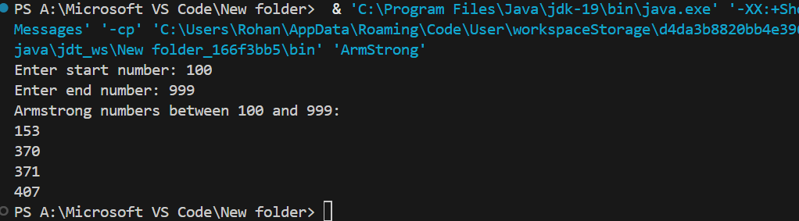

**Assignment 2**

import java.util.Scanner;

public class EmpSalary {

    public static void main(String[] args) {

        Scanner scanner = new Scanner(System.in);

        int choice = 1;

        int i = 1;

        while(choice == 1){

            System.out.print("Enter Employee Basic Salary: ");

            double basicSalary = scanner.nextDouble();

            double HRA, DA;

            if(basicSalary > 15000){

                HRA = basicSalary * 0.20;

                DA = basicSalary * 0.60;

            } else {

                HRA = basicSalary * 0.20;

                DA = basicSalary * 0.60;

            }

            double grossSalary = basicSalary + HRA + DA;

            System.out.println("Employee " + i + " Gross Salary: " + grossSalary);

            i++;

            System.out.print("Do you want to enter another employee? (1 for Yes): ");

            choice = scanner.nextInt();

        }

        scanner.close();

    }

}

**OUTPUT:**

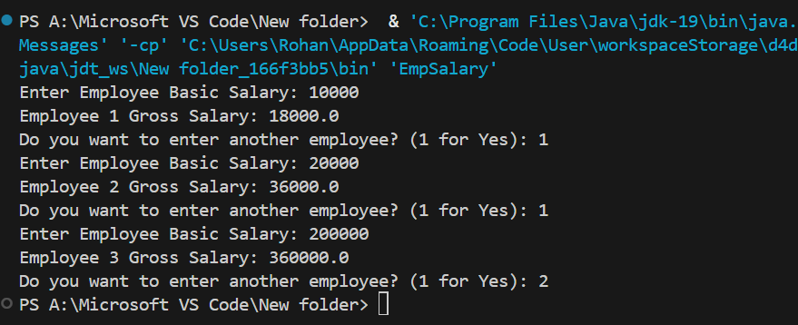

**Assignment 3**

import java.util.Scanner;

public class evenOdd {

    public static void main(String[] args) {

        Scanner scanner = new Scanner(System.in);

        int oddNo = 0;

        int evenNo = 0;

        System.out.print("Enter numbers(-1 to stop): ");

        int number = scanner.nextInt();

        while (number != -1) {

            if (number % 2 == 0) {

                evenNo++;

            } else {

                oddNo++;

            }

            number = scanner.nextInt();

        }

        System.out.println("Total even numbers: " + evenNo);

        System.out.println("Total odd numbers: " + oddNo);

scanner.close();

    }

}

**OUTPUT:**

